Lab 8

More on Timers Capture Mode

Spring 2025

Submitted by: Mohsin Sajjad

Registration No: 22pwsce2149

Class Section: A

“On my honor, as student of University of Engineering and Technology, I have neither given nor received unauthorized assistance on this academic work.”



Student Signature: ______________

Submitted to:

Engr. Faheem Jan

Month Day, Year (20 04, 2025)

Department of Computer Systems Engineering

University of Engineering and Technology, Peshawar

More on Timers Capture Mode

TASKS:

Capture event ( button press on P1.6 ) and toggle LED on each capture use rising edge.

CODE:

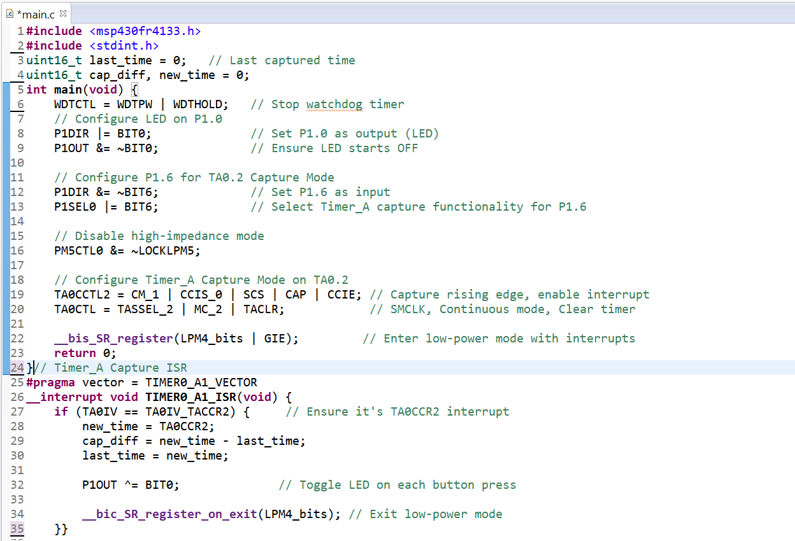

OUTPUT:

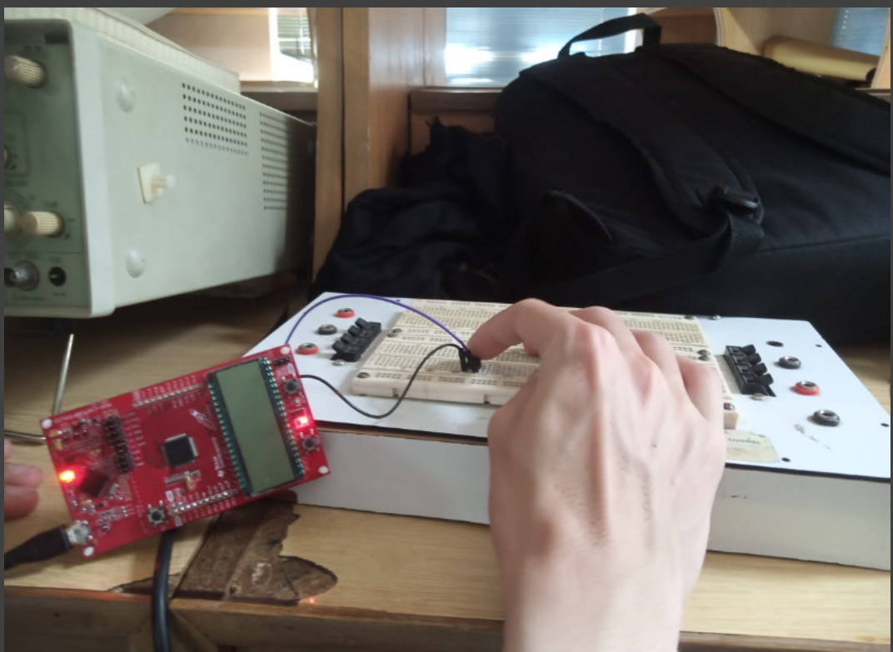

conclusion:

This code sets up a timer on the MSP430 to measure time between rising edges (like button presses) on pin P1.6. Each time an edge is detected, it calculates the time difference and toggles the LED on P1.0. It uses capture mode with interrupts and stays in low-power mode until triggered.

Task 2:

Capture event ( button press on P1.6 ) and toggle LED on each capture use falling edge.

CODE:  
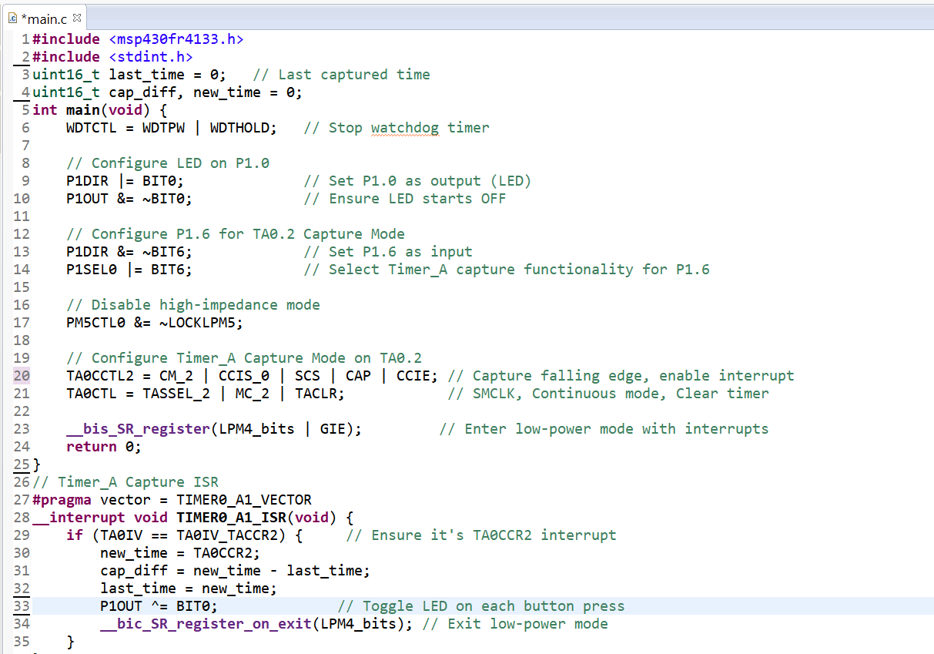

OUTPUT:

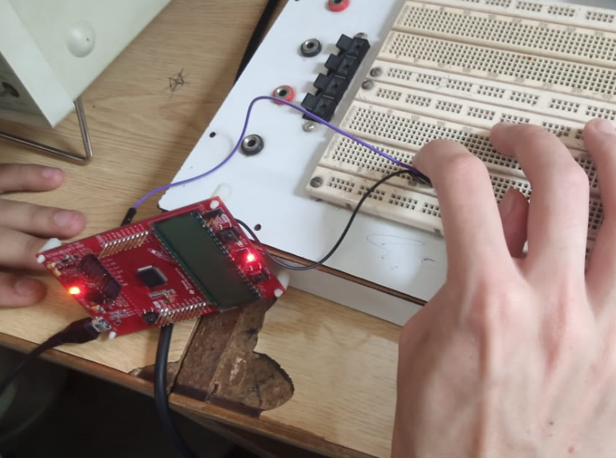

CONCLUSION:

This code measures the time between falling edges (like button releases) on pin P1.6 using Timer_A in capture mode. Each time a falling edge is detected, it calculates the time difference and toggles the LED on P1.0. It runs in low-power mode and wakes up only when an interrupt occurs.

TASK 03:

Capture event ( button press on P1.6 ) and toggle LED on each capture both rising and falling edge.

CODE:

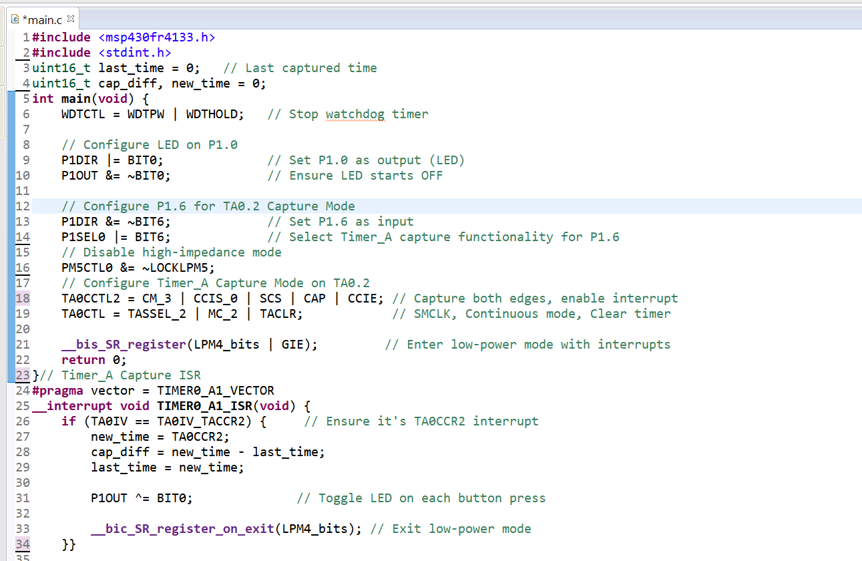

OUTPUT:

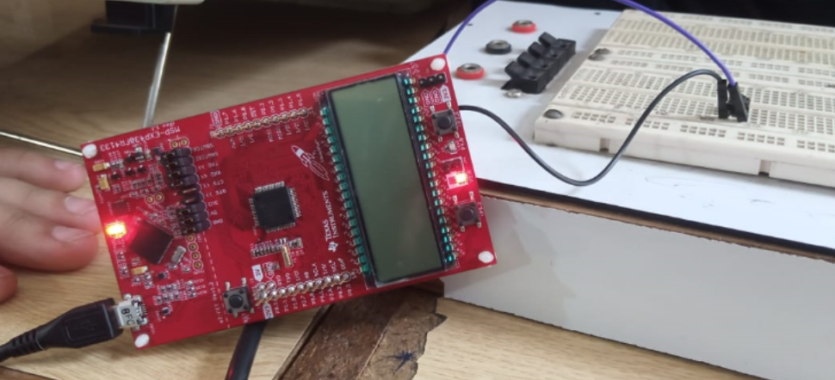

CONCLUSION:

This code uses Timer_A to capture both rising and falling edges on pin P1.6. It measures the time between each edge and toggles the LED on P1.0. The microcontroller stays in low-power mode and wakes up only when an edge is detected.

Task 04:  
Display the captured event on seven segment display . If the event occur for the first time display 1 for the second time display 2 and capture upto 9 .

CODE:  
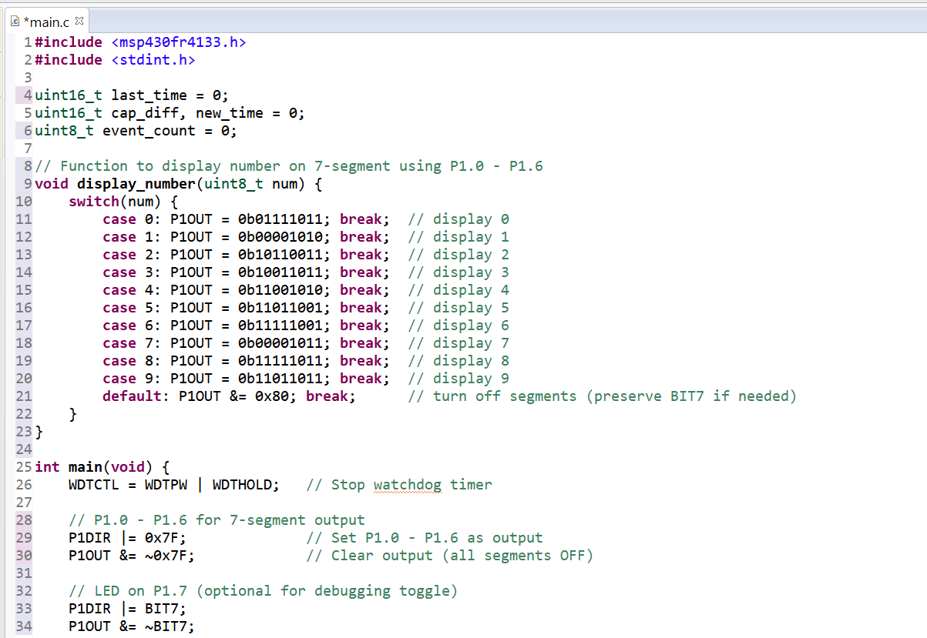

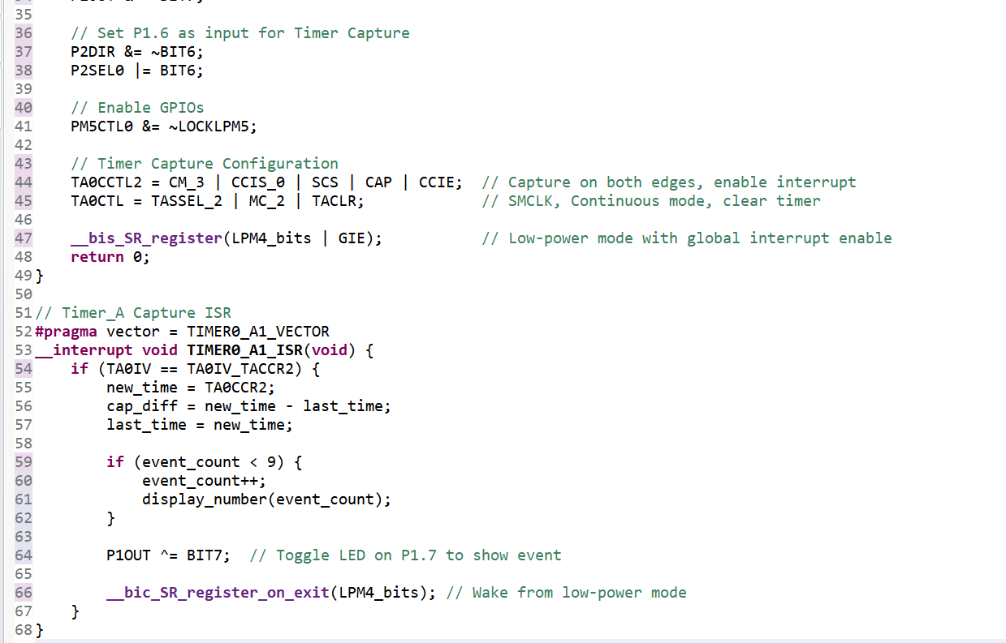

Output:  
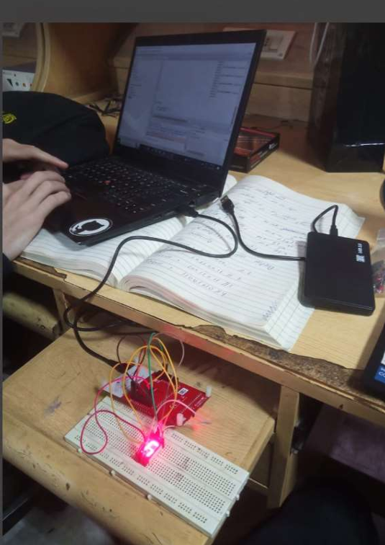

Conclusion:  
This code captures events on a rising or falling edge from a timer input (P1.6) and displays the count on a 7-segment display (P1.0 - P1.6). The event count is displayed from 1 to 9, and the LED (P1.7) toggles with each event. The system operates in low-power mode with interrupts enabled, efficiently counting and displaying without delays.